Open Call for Appointment of an Independent Chair for Luton Arts and Culture Strategy Group
Luton Arts and Culture Strategy Group is seeking a new Independent Chair to play a leading role in the development of its work over the next 18 months.
We are entering an exciting period for Arts and Culture in Luton, having secured £1.2m of Arts Council England Place Partnership Funding last year to deliver the Luton Arts Programme, which launched in April 2025, as well as funding agreed to develop a Cultural Compact in the town beyond this. Luton is also aiming to build on the success of the Radio 1 Big Weekend which took place in Luton in 2024 and opportunities for cultural regeneration linked to over £5 billion of inward investment in the town. All partners in the Arts and Culture Strategy Group are signed up to Luton’s 2040 Vision, which includes a key focus on transforming lives through arts, culture and heritage.
The new Independent Chair will bring vision and purpose to accelerate the growth of Arts and Culture in Luton. The ideal candidate will have outstanding experience of leading strategic Arts and Culture development in a place-based setting, while building strong links between creative leaders and the wider community, as well the ability to open up new opportunities for Luton to transform the lives of our citizens through arts and culture.

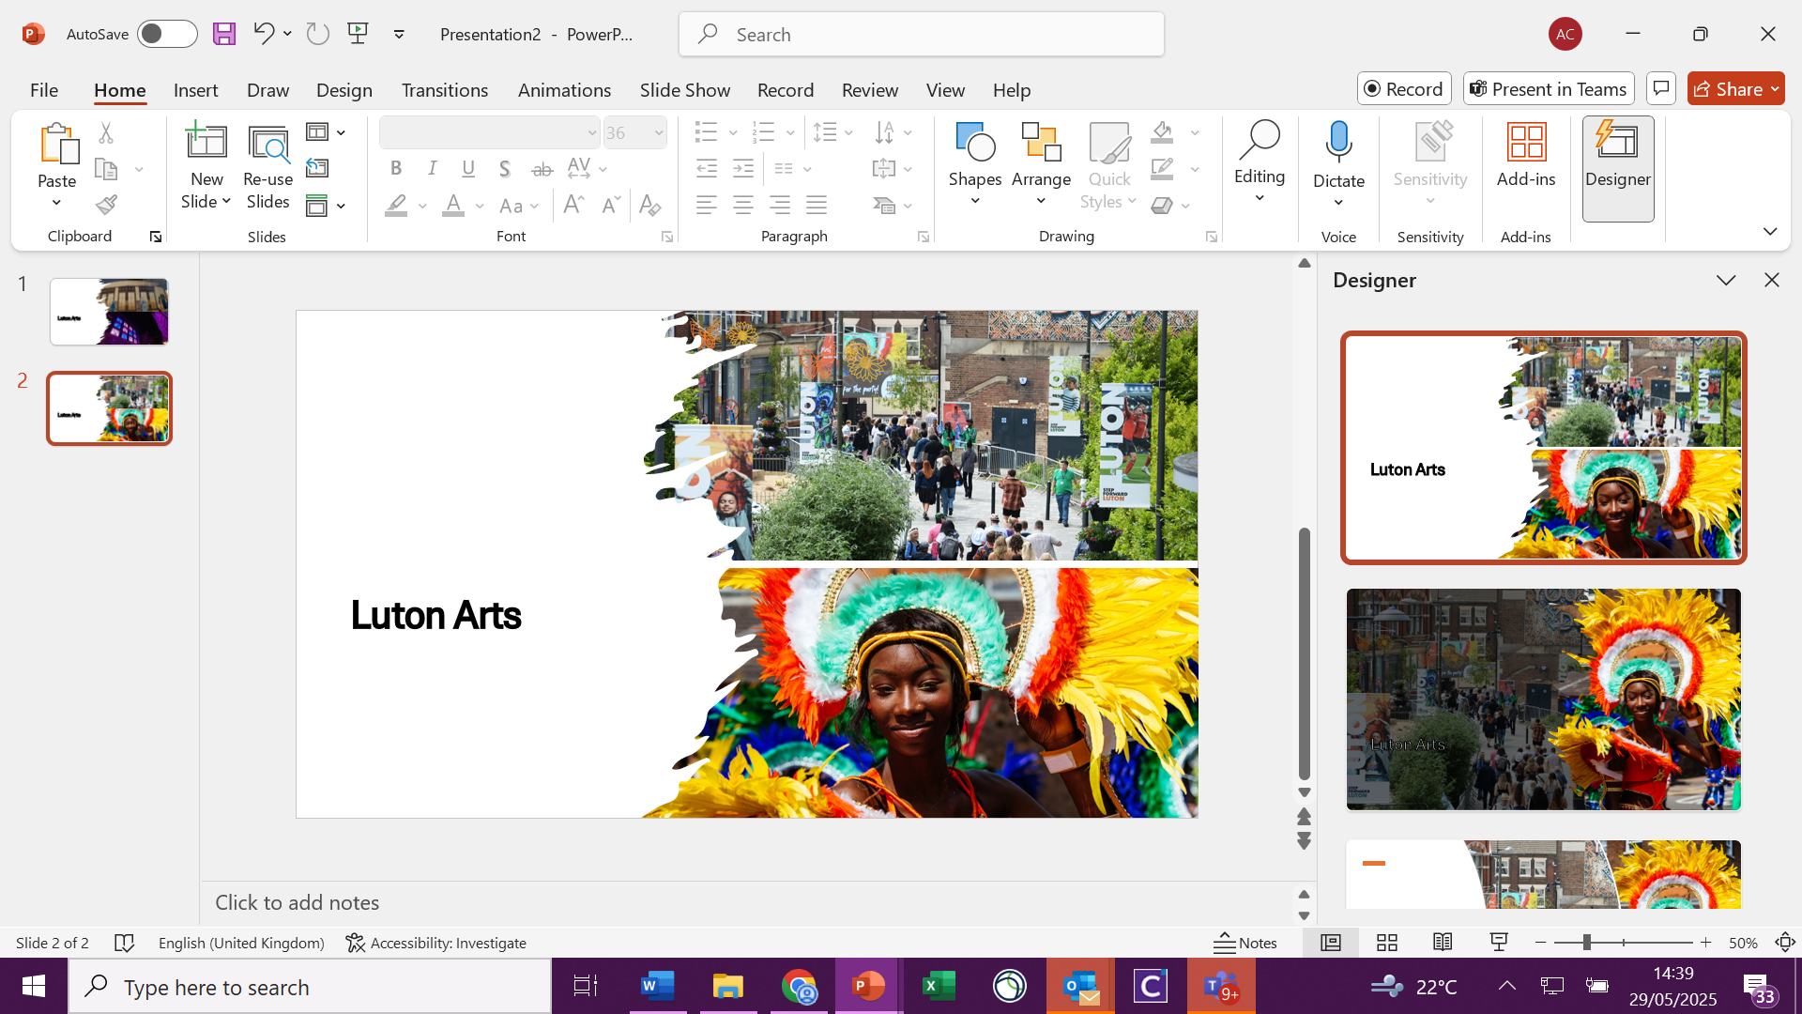
Luton Arts and Culture Strategy Group
Luton’s Arts and Culture Strategy Group exists to provide leadership and partnership working to deliver arts and culture in Luton. The terms of reference for the group include delivering on Luton’s Arts and Culture Strategy, Harnessing Momentum. This Strategy is due for renewal in 2027.

Membership of the Arts and Culture Strategy Group currently includes the following organisations and NPOs:


- Active Luton
- Arts Council England
- Clore Leadership
- Luton Council
- Luton Creative Forum Steering Group
- Music 24
- Revoluton Arts
- Tangled Feet
- The Culture Trust, Luton
- UK Centre for Carnival Arts
- University of Bedfordshire

The Role: Job Description
Duration: 18 months
Time commitment: 12-30 days (9 meetings over an 18-month period with approximately 1-3 days’ work required per meeting).
Remuneration: £500 per day
Resources: The Chair will be supported by the council’s Culture and Creativity Team who will be responsible for administration of meetings, booking learning visits, conducting research and writing of strategy documents. The Chair will also be able to draw upon the extensive capacity and expertise of partners in the Arts and Culture Strategy Group to support delivery of key pieces of work. The Chair will be responsible for the Arts and Culture Strategy Group development budget, to be used as agreed by the group as a whole.
The final work programme for the Independent Chair will be agreed once a suitable candidate has been appointed, but is likely to include the following:
- Chair a total of 9 Arts and Culture Strategy Group meetings over an 18-month period.
- Steer the development of the Arts and Culture Strategy Group, including:
  - Updating the group Terms of Reference, with clear roles and responsibilities for all member organisations.
  - Development of a new model for outreach and engagement that increases representation of Luton’s super-diverse community within Arts and Culture leadership.
  - Work with appointed vice-chairs to develop their role as future arts and culture strategy leaders.
  - Provide strategic leadership to the Luton Arts Programme and its legacy planning, including development of exit strategies for the programme, plans to address identified needs including access to spaces and resources for creatives and a talent development offer.
- Provide strategic leadership in the development of a new Arts and Culture Strategy.
- Provide strategic leadership to the group in developing other strategic work, including:
  - Creation of an audience development plan beyond 2027 that builds on the legacy of Luton Arts
  - Development of a Net Zero roadmap for Arts and Culture
  - Continuation of an Equality Diversity and Inclusion (EDI) Framework established in Luton Arts Programme
  - Creation of a Cultural Compact in Luton
- Provide links for the Strategy Group to wider opportunities, funding streams and learning from best practice in other places.

The Role: Person Specification
We are seeking a candidate with a broad range of skills and experience. The successful candidate will need to meet the essential criteria for independence, and the panel will consider appointing the candidate with the most suitable blend of the desirable skills, knowledge and experience outlined in the person specification.
Essential Criteria | The successful candidate must bring a degree of independence to the role. For this reason, we will not consider applications from any elected members within Luton Council or anybody that has a formal role within the governance arrangements of any Arts and Culture Strategy Group partners.
Experience  Desirable | Extensive and demonstrable experience of leading or chairing strategic partnership groups in an arts and culture setting, including experience of developing leadership and establishing clear roles and responsibilities for members.  Experience of increasing engagement and representation of super-diverse communities within strategic leadership groups.  Demonstrable experience of achieving transformational change in arts and culture delivery, leadership and programmes.  Experience of working within the context of Arts Council funded programmes, such as Place Partnerships or Cultural Compact funding.  Experience of working within the Luton place context or a demonstrably similar local context.
Skills and Abilities  Desirable | Ability to effectively lead and chair a group of cultural leaders to successfully enable effective collaborative and strategic working.  Demonstrated ability to work with and develop diverse groups and partnerships, fostering collaboration and trust in complex contexts. Proven skills in facilitation of groups to work as cohesive, high-functioning teams.  Ability to engage effectively with and embed the voice of super-diverse communities within strategic leadership.  Ability to see the bigger picture for cultural transformation and translate this into strategic plans.  Ability to identify and unlock opportunities for arts and culture development, including funding and investment opportunities and best practice learning from other places, including building new and lasting connections with key external stakeholders.
Specialist Knowledge / Qualifications  Desirable | Exceptional knowledge of arts and culture development across a variety of place-based settings nationally or internationally.  Working knowledge of arts council funded programmes and other external funding sources related to arts and culture.  A relevant qualification in cultural leadership, place-making leadership or equivalent relevant experience.  Specialist knowledge of any of the following areas of arts and culture strategy planning:  - Programme legacy building and funding sustainability planning.  - Audience development plans.  - EDI framework development.  - Environmental sustainability in arts and culture.  Strong understanding of the Luton context or a demonstrably similar location.

Appointment Process
Candidates should submit a CV and personal statement or alternatively a short video outlining how they meet the person specification and why they are interested in the role to: lutonarts@luton.gov.uk .
Applications should be submitted by 27th June 2025.
Shortlisted candidates will be invited to an interview process with the Arts and Culture Strategy Group members in July, with the aim to appoint a successful candidate by August 2025.
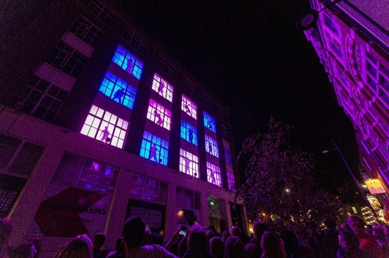
Further Information and Background Reading
If you would like to have an informal conversation about the role, please email lutonarts@luton.gov.uk with your name and contact details.
Please use the links below for background reading:
Harnessing Momentum: Our Strategy for Arts, Culture and the Creative Industries in Luton 2027-2027
lutonarts.co.uk

